**Experiment-1**

Rate Study in a Plug Flow Reactor

*18CH10071, Anshuman Agrawal*

**Objectives**

1. To determine the order of reaction between sodium hydroxide and ethyl acetate using a plug flow reactor.
2. To find the rate constant at a particular temperature.

**Theory**

Stoichiometric Equation:

NaOH + CH3COOC2H5 → CH3COONa + C2H5OH

1. (B) (C) (D)

Mole balance: $\frac{V_{R}}{F_{A_{0}}}$ $=$ $\int_{0}^{X_{A}}{\frac{{dX}_{A}}{{-r}_{A}}}$

Rate Equation: ${-r}_{A}=k_{2}C_{A_{o}}^{2}(1-X_{A})(M-X_{A})$

Where $M= \frac{C_{B_{0}}}{C_{A_{0}}}$, XA = conversion of A, k2 = rate constant

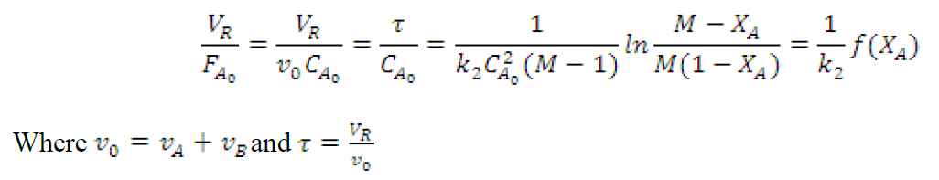

**Schematic**

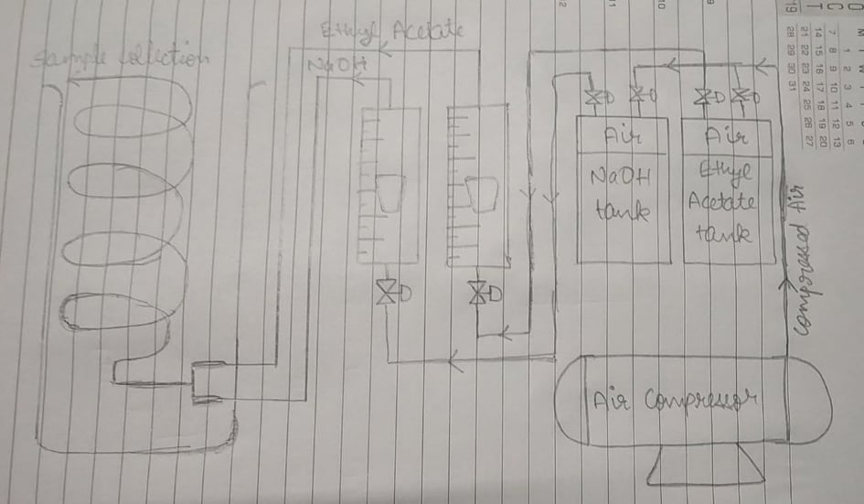

**Observations**

Strength of Succinic Acid = N/50 = 0.02 N = 0.01 M (dibasic acid)

CA0 (before mixing) = 0.049 mol/ L

CA0 (after mixing) = 0.0245 mol/ L

CB0 (before mixing) = 0.1 mol/ L

CB0 (after mixing) = 0.05 mol/ L

Reactor volume = 0.724 L

Length of coil = 609.6 cm

Inside diameter of tube = 1.23 cm

M = 2.04

|  |  |  |  |  |  |  |
| --- | --- | --- | --- | --- | --- | --- |
| **Flow Rate (LPH)** | **τ (sec)** | **CA0**  **(mol/ L)** | **Titre Volume (ml)** | **XA** | **Average XA** | **f (XA)** |
| 7.5 | 173.76 | 0.0245 | 1.7 | 0.722 | 0.706 | 1280.57 |
| 1.8 | 0.706 |
| 1.9 | 0.690 |
| 10 | 130.32 | 2 | 0.673 | 0.635 | 1017.12 |
| 2.2 | 0.641 |
| 2.5 | 0.592 |
| 12.5 | 104.26 | 2.5 | 0.592 | 0.587 | 873.01 |
| 2.5 | 0.592 |
| 2.6 | 0.576 |

**Sample Calculations**

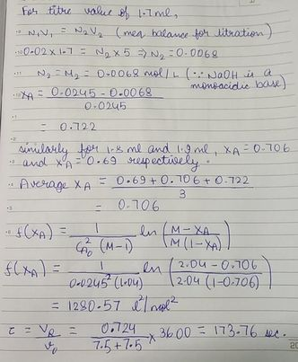

**Plot**

**Results**

Slope of above plot = 5.8846 l2 mol-2 s-1

Rate constant = slope × CA0 = 5.8846 × 0.0245 = 0.144 l mol-1 s-1

Therefore, the rate constant of given reaction at existing temperature conditions is **0.144 l mol-1 s-1**

**Discussion**

* The conversion is seen to decrease with increasing flow rate which seems logical given the residence time is decreasing.
* Rotameters are one possible source of error because the marker inside never stays in full equilibrium state therefore, there is always a very small error adding to the system.
* During titration, the final solution is not exactly neutral since phenolphthalein changes colour at pH > 7.
* Care must be taken that the phenolphthalein is not added in excess while titrating to the mixture.
* During titration, another possible error can occur due to parallax in taking the titre value if the meniscus is not observed carefully.

**Conclusion**

With this assumed 2nd order reaction taking place in a PFR, we can easily observe the desired results and trends between all relevant values. The rate constant value obtained for the reaction occurring in the PFR is a reasonable value considering the existing temperature conditions.